***PROCESS***

1 As defined in Best Practices, how does one determine that a Service once installed  
is actually running on the system? “Sudo systemctl status vsftpd” Provide an example of the command and a  
screen shot of that confirmation for the FTP Service you installed

2 The services command was one way to determine the state of a Service. What  
other commands can be utilized to determine the ports status? “Sudo netstat -tuln | grep 67”Provide a  
screenshot as an example examining the availability of the DHCP Service you  
installed

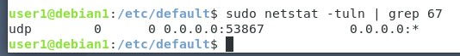

***DHCP***

3 Management has asked that a DHCP subnet be added to the existing DHCP server.  
3.a Subnet: 172.16.45.0  
3.b Netmask: 255.255.255.0  
3.c Gateway address: 172.16.45.1  
3.d Beginning range: 64  
3.e Ending range: 200

Provide a screenshot of the properly formatted DHCP specification for this LAN  
segment

***Samba***

4 Create a backup copy of your /etc/samba/smb.conf file. Provide a screenshot of the  
output of the testparm utility for Samba.



